1. Download Terrain Tools in the [**Unity Asset Store**](https://assetstore.unity.com/packages/2d/textures-materials/nature/terrain-tools-sample-asset-pack-145808)
2. Go to Unity and click **Download** then **Import** twice
3. Find the **Samples** folder to look for the Terrain Tools
4. Not only did this bring in textures it also gave me access to different brushes

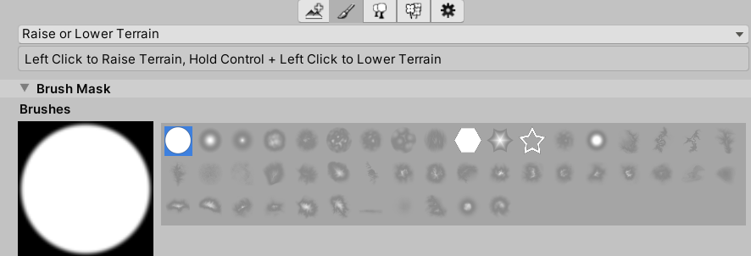

1. I used terrainstamp_mountain03
2. 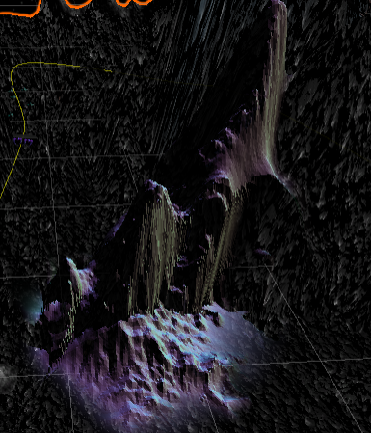

Trees

1. Click on the Paint Trees tool



1. Click **Edits Trees > Add Trees**
2. Click on the **Tree Prefab** field and in you Standard Assets there were Trees included.
3. Find a tree, Select it, and then click **Add**

Now you can paint Trees as a texture. We don't want to get there and just be like trees everywhere because there is a performance cost to trees, particularly if they're relatively high model.

1. **Tree Density** controls how many trees will be painted.

